Create the K8s EKS,further you have to do the deployment of the Nginx application and access the application outside the cluster.

KUBERNETES SERVICES

Kubernetes services act as an abstraction layer that exposes the applications in the running pods to other services or external clients. They provide a stable endpoint and load balancing features for accessing pods within a kubernetes cluster. It provides a seamless communication between different parts of an application.

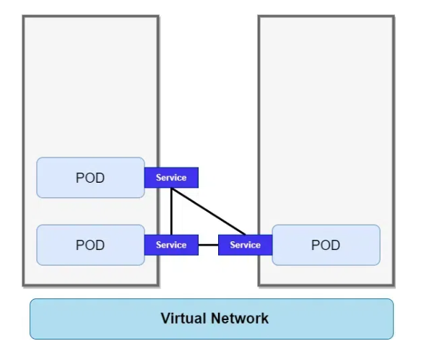

Defining a Kubernetes Service

In the kubernetes cluster, there are no.of objects which are having there own use cases and individual advantages. Same way service is part of objects which are present in kubernetes. To create an object or operate an object you can use the kubectl tool.

Example

apiVersion: v1
kind: Service
metadata:
name: deployment-service
spec:
selector:
Tomcat: deploymentapp
ports:
- protocol: TCP
port: 80
targetPort: 8080

Port Definitions

In the kubernetes service, there is one section called targetPort in the nodePort service instead of using the port number you can directly use the name of the pods.

Example

kind: Pod
metadata:
name: tomcat
labels:
deployemnt: deployemnet-java
spec:
containers:
- name: tomcat
image: tomact:latest
ports:
- containerPort: 8080
name: http-deplyment-port

---
apiVersion: v1
kind: Service
metadata:
name:tomcat-service
spec:
selector:
deployemnt: deployemnet-java
ports:
- name: name-of-service-port
protocol: TCP
port: 80
targetPort:http-deplyment-port

Services Without Selectors

This type of service will be exposed to all the pods in the kubernetes cluster. If the service is having selectors then that service will be exposed to only certain pods in the kubernetes cluster. We can use this special case of pods for different situations as the following:

Example

apiVersion: v1
kind: Service
metadata:
name: tomcat-service
spec:
ports:
- protocol: TCP
port: 80
targetPort: 8080

You can map the service to the required object by using the network address and port with the help of the Endpoint slice object manually.

EndpointSlices

EndpontSlices are the object available in the kubernetes cluster from Kubernetes v1.21 [stable]. Endpontslice main function is to break endpoints into smaller manageable segments. The limit of pods that can find in each endpoint slice was 100 pods. The new endpoint slice will be created only when the Endpointslice is filled up with 100 endpoints.

Custom EndpointSlices

The custom name can be given to endpoint slices when you create a new endpoint slice. By using the following EndpointSlices you can create custom Endpoint Slices.

Example

apiVersion: discovery.k8s.io/v1beta1
kind: EndpointSlice
metadata:
name: my-custom-endpointslice
spec:
endpoints:
- addresses:
- 10.1.2.3
ports:
- name: http
protocol: TCP
port: 80

Application Protocol

The application protocol is the field where you can mention the type of protocol that a specific service is listening to. The protocol can be anything that depends upon our requirements here are the some of application protocols.

TCP

UDP

HTTP

HTTPS

Mostly the service will listen to the TCP protocol. If the service is TCP protocol the service will be load balancing service and if it is HTTP protocol the service type will be ingress.

Multi-Port Services

Multi-port Service allows you to expose different protocols to the same service or different applications on the same service. You can configure multiple ports using the object in kubernetes called to service.

Example

apiVersion: v1
kind: Service
metadata:
name: tomcat-service
spec:
ports:
- name: http
port: 8080
protocol: TCP
- name: https
port: 43
protocol: TCP

By using the yaml which is mentioned above you can expose multiple ports but the IP address and DNS name will be the only one with that you can use various services.

Load Balancers With Mixed Protocol Types

The service type LoadBalancer can have multiple ports but it should have only one protocol and which is supported by the cloud provider. You can have a kubernetes service that exposes protocols like TCP and UDP ports, which is called a mixed protocol service.

Choosing Your Own IP Address

Kubernetes will assign the IP address from within the service-cluster-ip-range CIDR range or you can choose your own customized IP address. You can reuse the DNS or IP address already in the kubernetes cluster. For reusing, you need to request while creating the service itself.
,
Example
apiVersion: v1
kind: Service
metadata:
name: tomcat-service
spec:
clusterIP: 10.10.10.10
ports:
- name: http
port: 8080
protocol: TC

Once you applied the above specification after that you can access the Tomcat application from the internet by using the IP address you mentioned in the yaml file our case it will be 10.10.10.10. You can also try the above yaml file to create your own customized IP address.

Choosing Your Own Port

While exposing the pod to the internet we will use service objects in the Kubernetes cluster. We will use mainly the nodePort service in Kubernetes while exposing the pod in Kubernetes. You can mention your own port in the yaml in the section which is called nodePort: <PortNumber>. On this port, the users can access the service from the internet and the service will listen on the port which you have mentioned.

Example

apiVersion: v1
kind: Service
metadata:
name: tomcat-service
spec:
type: NodePort
selector:
app: Webapp
ports:
- port: 80
targetPort: 8080
# Control Plane in kubernetes will allocates an default
IPaddress which is in the range of various between 30000-32767.
nodePort: 300023
Service type

Types of Services

There are four major types of services which are having their advantages in their perspective as explained following.

ClusterIP

NodePort

LoadBalancer

ExternalName

Headless

1. ClusterIP

When we create a service we will get one Virtual IP (Cluster IP) it will get registered to the DNS(kube-DNS). Using this Other Pds can find and talk to the pods of this service using the service name. Service is just a logical concept, the real work is being done by the “kube-proxy” pod that is running on each node. It redirects requests from Cluster IP(Virtual IP Address) to Pod IP.

Example

apiVersion: v1
kind: Service
metadata:
name: nginxsvc
spec:
selector:
app: nginx
type: ClusterIP
ports:
- name: http
port: 80
targetPort: 80
protocol: TCP

ClusterIP Service ( Internal Service)

In this service type when a Client makes a request then that request is first forwarded to the ingress controller and the ingress controller forwards it to the cluster service and then this service forwards it to the appropriate pod. When there are many replicas of a pod then these replicas serve as the endpoints of service and here service also works as a load balancer and forwards requests to the pod replica having the least load. This service is an Internal service because external traffic cannot directly access the cluster service. It can only be accessed via the Ingress Controller.

Example:

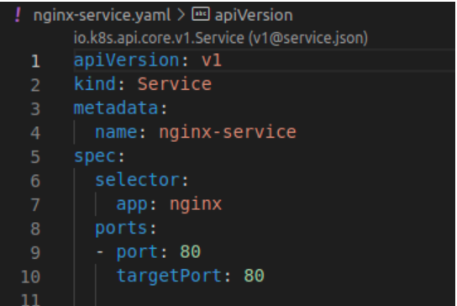

Also, the ClusterIP service is the default service if we do not specify the service type in the config file as in the example above.

Now we can create this service by applying the following command:

$ kubectl apply -f [file-name]

2. NodePort Service (External Service)

In NodePort Service, external service has access to a fixed port on each Worker Node. In this case, instead of ingress, the browser request will directly come to the node at the port defined in the service config file and be exposed at the node port. The node port can range between 30000 to 32767.

Example:

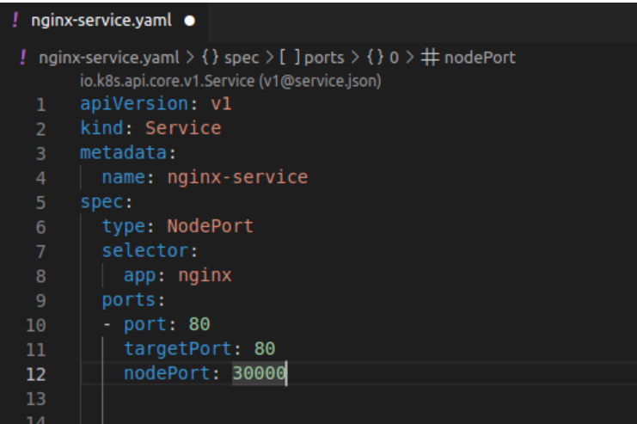

Now we can create this service by applying the following command

$ kubectl apply -f [file-name]

3. LoadBalancer

Exposes the service externally using a cloud provider’s load balancer. NodePort and ClusterIP services, to which the external load balancer will route, are automatically created. If you are using a custom Kubernetes Cluster (using minikube, kubeadm, or the like). In this case, there is no LoadBalancer integrated (unlike AWS EKS or Google Cloud, KOPS, and AKS). With this default setup, you can only use NodePort.

Example

apiVersion: v1
kind: Service
metadata:
name: javawebappsvc
spec:
ports:
- port: 80
targetPort: 8080
selector:
app: javawebapp
type: LoadBalancer

5. Headless Service

Headless is a type of service in kubernetes that doesn't assign a ClusterIP to the service instead it returns a DNS records for individual pods. It allows the direct communication with pods without using a load balancer.

The following yaml based configuration file of Headless service:

apiVersion: v1
kind: Service
metadata:
name: my-headless-service
spec:
clusterIP: None
selector:
app: my-app
ports:
- protocol: TCP
port: 80
targetPort: 8080

We can access the kubernetes service using the services such as ClusterIP, NodePort ot LoadBalancer IP along with defining the port number. Clients within the cluster uses the service name and port. And the clients who are outside the cluster uses the cluster's external IP or DNS name. The following are the step by step guide for accessing the kubernetes service.

Step 1: Create A Pod

Firstly create a yaml file for defining a pod application with a file name my-pod.yaml

The following is the pod yaml file code that is used here:

apiVersion: v1
kind: Pod
metadata:
name: my-pod
spec:
containers:
- name: my-container
image: nginx
ports:
- containerPort: 80

After once the file has created, then apply the definitions for creating the pod resources using the following command:

kubectl apply -f my-pod.yaml

Accessing Service Using NodePort

Step 2: Create A Service With NodePort

For accessing the pod application externally from the cluster, we have to expose the service using NodePort. For that we creating service yaml file with name my-service.yaml .The file code looks as follows:

apiVersion: v1
kind: Service
metadata:
name: my-service
spec:
selector:
app: my-app
ports:
- protocol: TCP
port: 80
targetPort: 80
type: NodePort

Apply the service yaml file definitions using the following command:

kubectl apply -f my-service.yaml

Step 3: Access The Service

Now, get the NodePort that is assigned to the service:

kubectl get svc my-service

Access the service using any node's IP and the NodePort as shown in below:

curl http://<node-IP>:<NodePort>

Accessing Application Using Service Type ClusterIP

Step 2: Create A Service Using ClusterIP

For creating a ClusterIP kind service to communicate with the application within the cluster, create a yaml file with name "my-clusterIP-service.yaml" as shown in the below:

apiVersion: v1
kind: Service
metadata:
name: my-service
spec:
selector:
app: my-app
ports:
- protocol: TCP
port: 80
targetPort: 80

Once, the my-clusterIP-service.yaml file is defined, then apply the definition to create the service as per requirement with ClusterIP type using the following command to apply.

kubectl apply -f my-service.yaml

Step 3: Access the Service Using ClusterIP

Access the service within the cluster using the service name will looks as follows:

curl http://my-service:80

Accessing Service Using Load Balancer

Step 2: Create A Service With Load Balancer

For creating a load balancer service, create a yaml file with name "my-loadbalancer-service.yaml" as shown in the below:

apiVersion: v1
kind: Service
metadata:
name: my-loadbalancer-service
spec:
selector:
app: my-app
ports:
- protocol: TCP
port: 80
targetPort: 80
type: LoadBalancer

After once created the my-loadbalancer-service.yaml file then apply the definition changes with the following command:

kubectl apply -f my-loadbalancer-service.yaml

Step 3: Access The Load Balancer

Fristly in this get the external IP address of the Load balancer with the following command:

kubectl get svc my-loadbalancer-service

Access the application using the service using the LoadBalancer's External IP:

curl http://<LoadBalancer-External-IP>:80

Accessing Service Using External IP

Step 2: Create A Service External IP

For creating a External IP service, create a yaml file with name "external-service.yaml" as shown in the below assuming that the IP is already available:

apiVersion: v1
kind: Service
metadata:
name: my-external-service
spec:
selector:
app: my-app
ports:
- protocol: TCP
port: 80
targetPort: 80
externalIPs:
- <External-IP>

After once created the external-service.yaml file then apply the definition changes with the following command:

kubectl apply -f external-service.yaml

Step 3: Access The Service using External IP

Access the service using the External IP as shown in the following:

curl http://<External-IP>:80

Accessing Service using Headless Service

Step 2: Create A Service of Headless Type

For creating a Headless service, create a yaml file with name "my-headless-service.yaml" as shown in the below assuming that the IP is already available:

apiVersion: v1
kind: Service
metadata:
name: my-headless-service
spec:
selector:
app: my-app
clusterIP: None
ports:
- protocol: TCP
port: 80
targetPort: 80

After once created the my-headless-service.yaml file then apply the definition changes with the following command:

kubectl apply -f my-headless-service.yaml

Step 3: Access Pods Directly via Headless Service

Now, get the IPs of the pods that are managed by headless service with the following command:

kubectl get pods -o wide

Use the Pod IPs to access the pods directly. The URL looks as follows:

curl http://<pod-IP>:80

Headless Services

Headless Services in Kubernetes comes with specifying the setting of `.spec.clusterIP` to None and doesn't provide the load balancing features with single IP allocation. Instead it facilitates to have a direct connections to the pods individually. It facilitates with interfacing the external service discovery mechanisms. DNS records, DNS services that are managed by Kubernetes provides endpoint IP's for these Headless Services.

Headless Service With Selector

Deployments are usually used for stateless applications. However, you can save the state of deployment by attaching a Persistent Volume to it and make it stateful, but all the pods of deployment will be sharing the same Volume, and data across all of them will be the same. SatefulSet is a Kubernetes resource used to manage stateful applications. It manages the deployment and scaling of a set of Pods and provides a guarantee about the ordering and uniqueness of these Pods.

Example

apiVersion: v1
kind: Service
metadata:
name: my-service
spec:
clusterIP: None
selector:
app: my-app
ports:
- name: http
port: 80
targetPort: 8080

When we are using the type of service you will use, you need to give the name "clusterIP: None".

Headless Service Without Selector

On without using the selectors features kubernetes doesn't able to create the ENdpointSlice objects. The configuration of DNS depends on the type of service, some of them discussed as follows:

For ExternalNames services, It configures DNS CNAME records.

For other types, DNS will generates A or AAAA records for mapping to all IP addresses of ther Service's ready endpoints.

Step 1: Deploy your Application

Deploy your application using a Deployment or Pod yaml file. Here we are taking deployment yaml configure file that is provided as follows:

apiVersion: apps/v1
kind: Deployment
metadata:
name: my-app
spec:
replicas: 3
selector:
matchLabels:
app: my-app
template:
metadata:
labels:
app: my-app
spec:
containers:
- name: my-app-container
image: nginx
ports:
- containerPort: 80

Apply the defined yaml configuration file with the following command:

kubectl apply -f deployment.yaml

Step 2: Create A Kubernetes Service

Create a yaml file for defining the service to the created deployment and making the application be exposed. The service configured yaml file is given as follows:

apiVersion: v1
kind: Service
metadata:
name: my-app-service
spec:
selector:
app: my-app
ports:
- protocol: TCP
port: 80
targetPort: 80
type: NodePort

Apply the service resource configuration containing yaml file using the following command:

kubectl apply -f service.yaml

Step 3: Access Your Application

Findout the NodePort that is exposed to the created service for the application with the following command:

kubectl get svc my-app-service

Now access your application using any node's IP and the NodePort.

curl http://<node-IP>:<NodePort>

Step 4: Optional: Use Ingress

If you want to provide the more advanced routing and external access control to the cluster. Consider on using the ingress resource along with the your service.

Deploying Application Using Kubernetes

In this we will walk through the process of deploying separate frontend and backend applications, and then exposing the frontend to be accessible. We'll be using fundamental Kubernetes objects like Deployments to manage our application pods and Services to provide stable network access.

Prerequisites

A running Kubernetes cluster (like the one you set up with kubeadm or yoou can also use minikube that spins up the cluster by itself).

kubectl command-line tool configured to communicate with your cluster.

Basic understanding of Docker containers and images.

1. Overview of the Deployment Workflow
The deployment of a distributed application in a cloud-native ecosystem involves two primary stages.

The first is containerization, where the application and its dependencies are packaged into a lightweight, standalone, executable unit known as a container image. This ensures environmental consistency and portability.

The second stage is orchestration, where these containers are deployed, scaled, and managed at scale.

2. Phase 1: Application Containerization with Docker

The foundational step is to containerize each tier of the application. Docker is utilized for this purpose, with a Dockerfile for each component defining the build instructions.

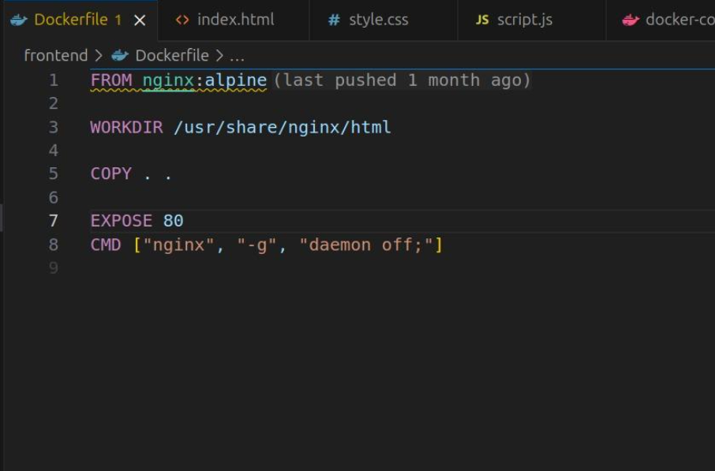

2.2. Containerizing the Backend

The backend, a Python-based Flask application, is containerized to package the application code and its library dependencies into a single portable image.

Dockerfile Analysis: The Dockerfile for the backend is structured to create an optimized and reproducible environment for the Python application.

FROM python:3.10-slim: It begins with a slim official Python base image to reduce the overall size.

COPY requirements.txt .: The dependencies file is copied into the image first.

RUN pip install -r requirements.txt: Leveraging Docker's layer caching, dependencies (which change infrequently) are installed in a separate step. This step is only re-run if requirements.txt changes.

COPY . .: The application source code (app.py) is copied into the image.

CMD ["python", "app.py"]: This defines the default command to execute when a container is started from this image, launching the Flask application.

The Backend Dockerfile:

# Use a slim Python image as the base
FROM python:3.10-slim

# Set the working directory inside the container
WORKDIR /app

# Copy the requirements file and install dependencies
COPY requirements.txt .
RUN pip install --no-cache-dir -r requirements.txt

# Copy the application code into the container
COPY . .

# Expose the port the app runs on
EXPOSE 5000

# Define the command to run the application
CMD ["python", "app.py"]

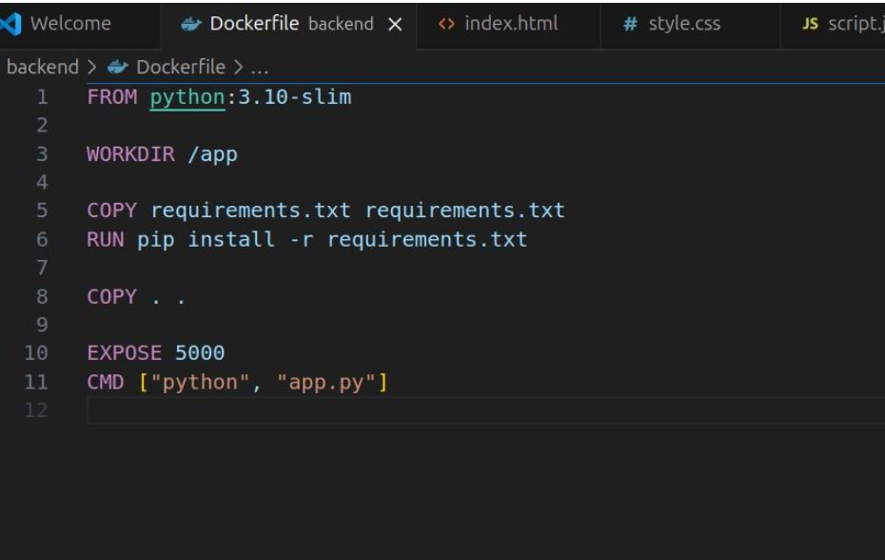

Once both Dockerfiles are created, the images are built using docker build and subsequently pushed to a container registry, such as Docker Hub, making them accessible to the Kubernetes cluster.

# Build and push the frontend image
docker build -t your-username/notes-frontend:latest .
docker push your-username/notes-frontend:latest

# Build and push the backend image
docker build -t your-username/notes-backend:latest .
docker push your-username/notes-backend:latest

On Successful Push you will be able to see it on your Dockerhub:

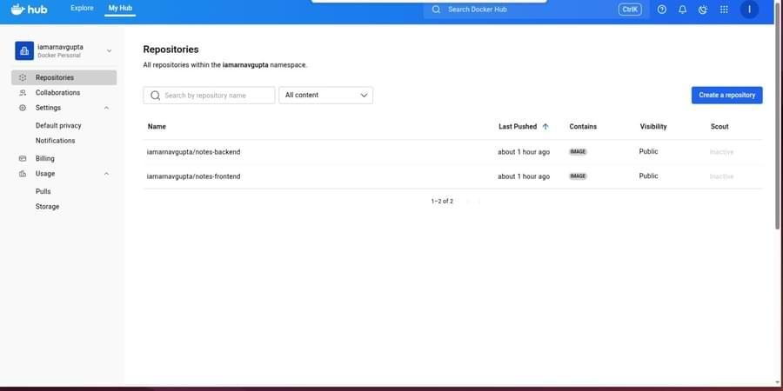

3. Phase 2: Orchestration with Kubernetes

With the container images available in a registry, the next phase is to deploy them in a Kubernetes cluster.

You can also set alias for a command. I have set the alias for kubectl as k. For this you can use the command :

alias k=kubectl

Step 1: Deploying the Backend Application

First, we'll create the backend of our application. A Kubernetes Deployment is the perfect tool for this. It ensures that a specified number of replica Pods are always running. If a Pod crashes, the Deployment controller replaces it automatically.

We will create a deployment named backend using a pre-built Docker image, with three replicas for high availability.

Execute the following command:

kubectl create deployment backend --image=iamarnavgupta/notes-backend:latest --replicas=3

This command tells Kubernetes to:

Create a new object of type deployment.

Name it backend.

Use the Docker image iamarnavgupta/notes-backend:latest for the containers.

Maintain 3 running replicas of the pod.

To verify that the deployment was successful, let's check the status of our deployments and pods.

kubectl get deploy

You should see your newly created backend deployment, along with any others you might have.

kubectl get pods --show-labels

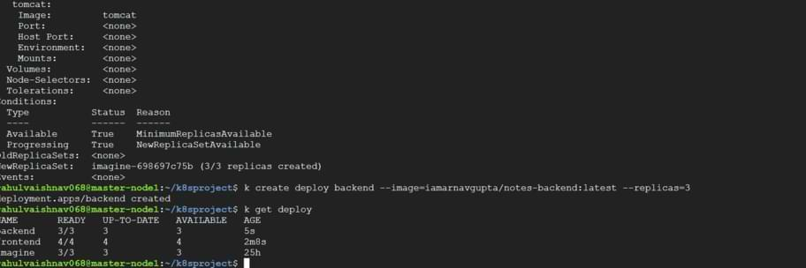

Step 2: Deploying the Frontend Application

Next, we'll deploy our frontend application in the same way. This time, we'll create a deployment named frontend with four replicas.

kubectl create deployment frontend --image=iamarnavgupta/notes-frontend:latest --replicas=4

Verify the Frontend Deployment:

kubectl get deploy frontend

And describe it to see more details:

kubectl describe deploy frontend

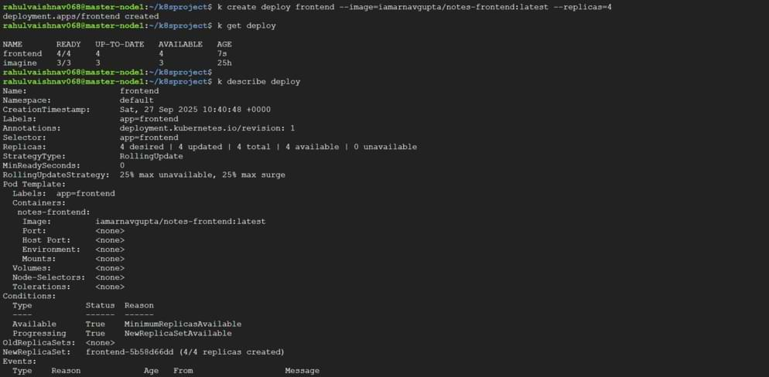

Step 3: Exposing the Frontend with a Service

Our pods are running, but they are not accessible from outside the cluster. Pods have their own internal IP addresses, which are ephemeral—they can change if a pod is recreated. To provide a stable network endpoint for our frontend, we need to create a Kubernetes Service.

We will use a NodePort service type, which exposes the service on a static port on each of the cluster's nodes.

Here is the YAML manifest for our service, let's call it node.yaml:

apiVersion: v1
kind: Service
metadata:
name: myapp-service
spec:
type: NodePort
ports:
- targetPort: 80
port: 80
nodePort: 30002
selector:
run: testp

kind: Service: Defines the object as a Service.
name: myapp-service: The name of our service.

type: NodePort: The type of service.

port: 80: The port the service will be available on within the cluster.

targetPort: 80: The port on the pods that the service will forward traffic to.

nodePort: 30002: The static port on the worker node where this service will be exposed.

selector: {run: testp}: This is the most crucial part. The service will automatically find all pods that have the label run=testp and send traffic to them.

Apply this configuration to your cluster:

kubectl apply -f node.yaml

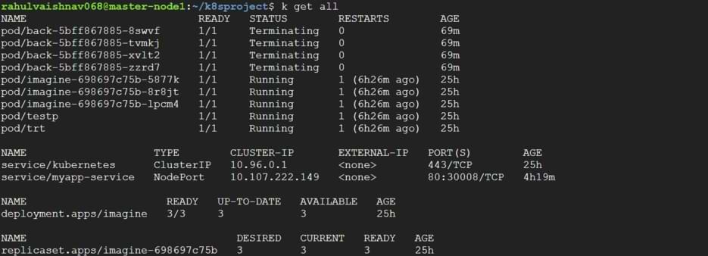

Step 4: Connecting the Service to the Pods with Labels

If you inspect the service now, you'll notice it doesn't have any endpoints. That's because no pods currently have the run=testp label. The power of Kubernetes is this loose coupling: a Service finds its Pods using labels, and we can add or remove these labels at any time.

kubectl get pods --show labels

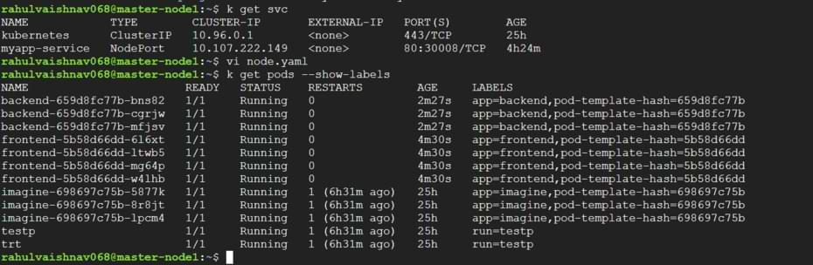

kubectl label pod frontend-5b58d66dd-mg64p run=testp

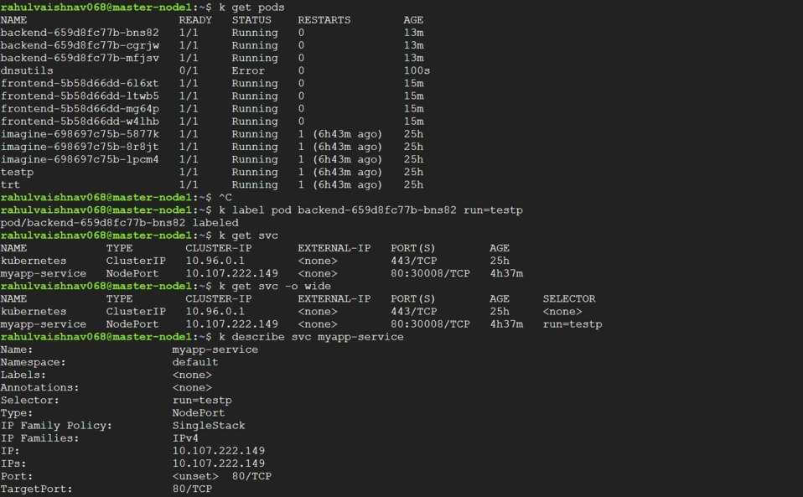

Step 5: Verifying Connectivity

Now that our service is linked to a frontend pod, let's verify everything is working. First, describe the service to see its details and, most importantly, its Endpoints.

kubectl describe svc myapp-service

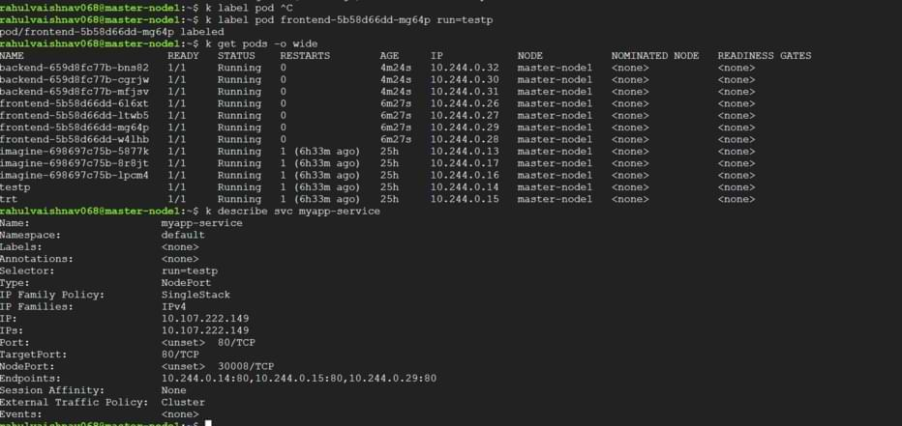

Notice the Endpoints field now lists the IP address and port of the frontend pod we labeled (10.244.0.29:80). This confirms the connection is made!

Finally, let's test the connection by sending a request directly to that pod's IP address from within the master node.

curl 10.244.0.29:80

The HTML output from the "Notes App" is returned, confirming that our Deployment is running and our Service is correctly routing traffic to it. You can also access this application from outside the cluster by navigating to <your-node-ip>:30002.

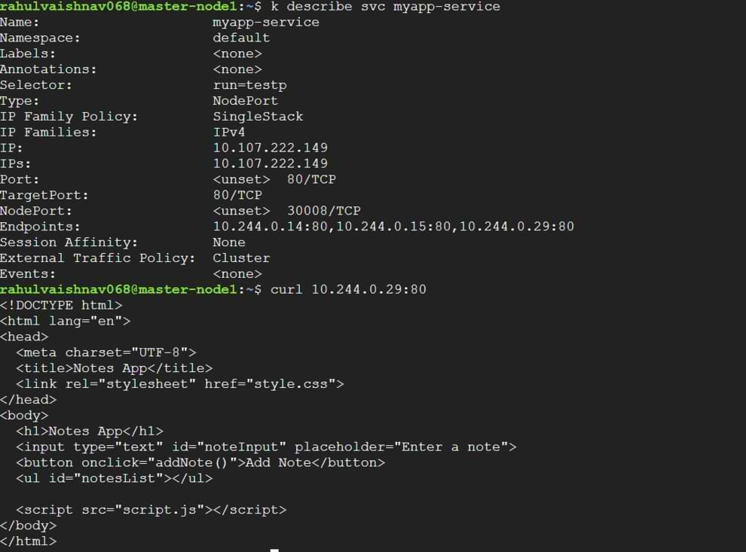

How to Deploy Nginx In Kubernetes

Step 1: Start the minikube

Firstly ensure the minikube software has downloaded in your system and configured its path in system environment.

Use the following command to start the minikube server:

minikube start

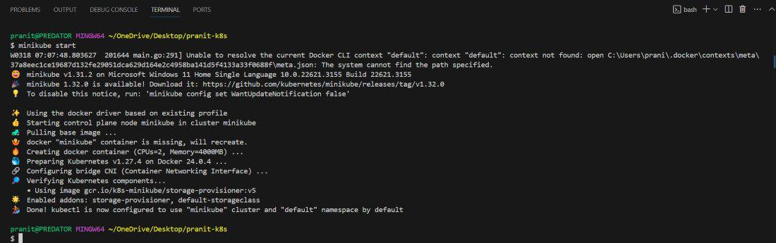

Step 2 : Create Kubernetes Deployment Yaml File Example

Create a deployment YAML configuration file . Here mention the NGINX image and container port. The following is the Deployment.yaml file.

apiVersion: apps/v1
kind: Deployment
metadata:
name: nginx
labels:
app: nginx
spec:
replicas: 1
selector:
matchLabels:
app: nginx
template:
metadata:
labels:
app: nginx
spec:
containers:
- name: nginx
image: nginx:latest
ports:
- containerPort: 80

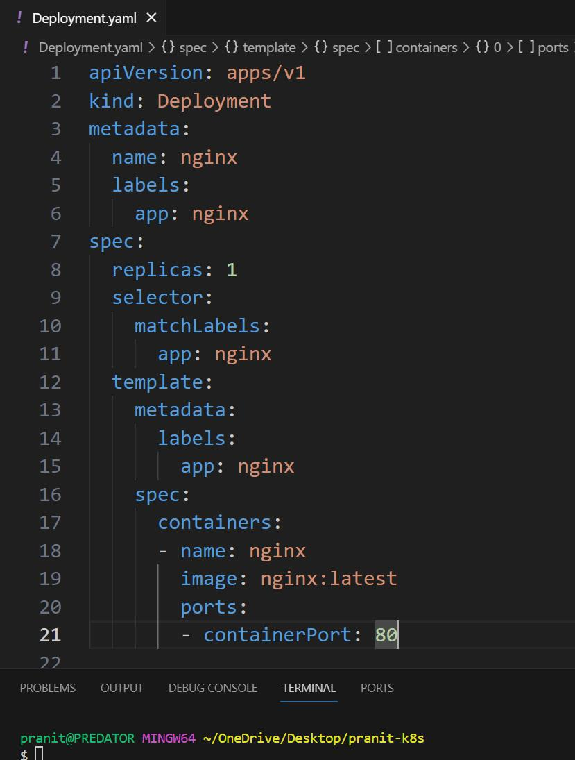

Step 3 : Create Kubernetes Service Yaml File Example

Create a service YAML configuration file . This will expose the NGINX at port 80 . The following is the Service.yaml file:

apiVersion: v1
kind: Service
metadata:
name: nginx-service
spec:
type: NodePort
selector:
app: nginx
ports:
- port: 80
targetPort: 80

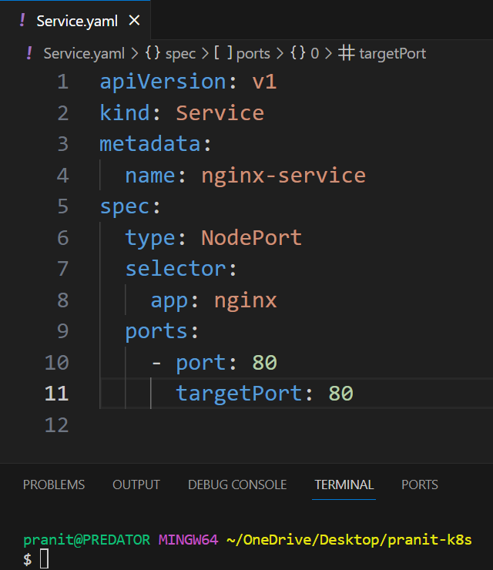

Step 4: Deploying Kubernetes Ngnix Deployment and Service Yaml Files

Apply all the YAML configuration file using kubectl

kubectl apply -f Deployment.yaml
kubectl apply -f Service.yaml

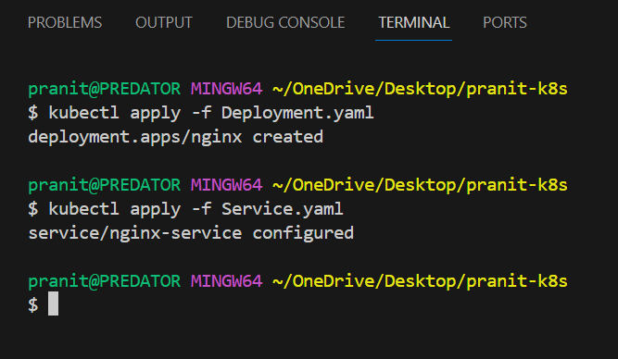

Here if you have used docker to run minikube then you have to write this additional command to access the service from your browser .

minikube service nginx-service

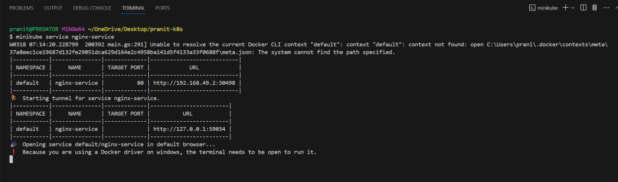

Step 5: Successful Deployment of Ngnix Service

Now to connect host IP with container port to see whether the NGINX service is deployed or not .

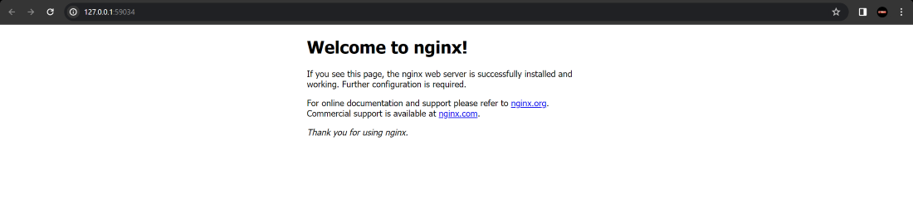

How to Deploy Nginx Pod in Kubernetes

Step 1: Create Nginx Pod Yaml File

Create a file with name nginx-pod.yaml and configure it, for reference use the following code:

apiVersion: v1
kind: Pod
metadata:
name: nginx-pod
spec:
containers:
- name: nginx-container
image: nginx:latest
ports:
- containerPort: 80

Step 2: Deploy Pod Yaml File

After save the pod configuration yaml file with nignx-pod.yaml then deploy the pod yaml file with the following command:

kubectl apply -f nginx-pod.yaml

Step 3: Verify the Pod

Check whether the pod has created successfully or not with the following command:

kubectl get pods

Step 4: Access Nginx Pod

If you want to access the pod from outside of the cluster, try on exposing it using the service or port forwarding. The following is the command for performing port-forwarding:

kubectl port-forward nginx-pod 8080:80

kubectl port-forward nginx-pod 8080:80

Kubernetes run Nginx Example
We can run the the pod with Nginx Image without any deployment using Kubernetes run. The command for this looks as follows:
kubectl run nginx --image=nginx --port=80

After once executing we can check the pods and deployments with the following commands:
kubectl get pods
kubectl get deployments

After running the above commands, you can clearly understands that kubernetes run command creates the pods without having deployment.

